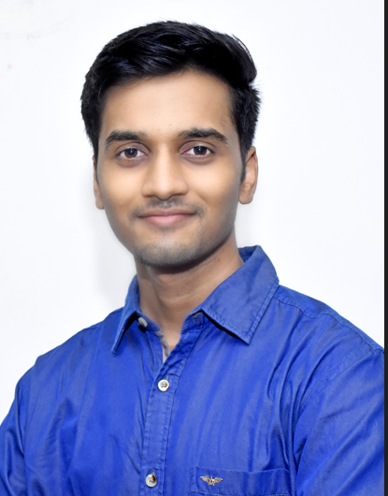

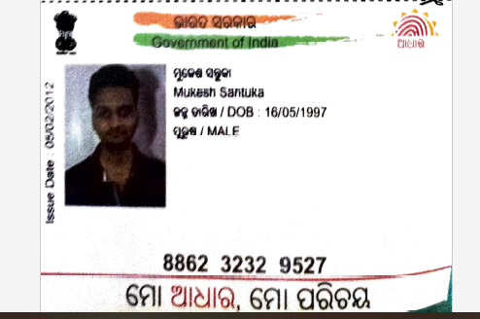

Vedio Link Data Platform Engineer(Python) _ Interview _Mukesh Santuka-20230908_150114-Meeting Recording.mp4mukesh.may97@gmail.com +91-7978387670 Bangalore, India https://www.linkedin.com/in/mukesh-santuka-291073172/

EXPERIENCE

Software Engineer II

HashedIn By Deloitte
 Jan 2022 – Present Bangalore, India
- Developed batch script after creating LLD (Low level Design considering all the optimization to make the job more eﬃcient) for syncing enterprise data of DB2 tables.
- Designed and implemented ETL script using pyspark in AWS Glue to process structured and unstructured data by integrat- ing more than 10 million of records from diﬀerent database.
- Used splunk to create dashboard for the error logs to minimize the eﬀorts to ﬁnd the bugs and resolve.
- Reduced the execution time of existing job by using broadcast join, ﬁltering redundant data before creating the dataframe and simplifying transformations.

Software Engineer

HashedIn By Deloitte
 June 2021 – Dec 2021 Bangalore, India
- Developed ETL script using Scala and spark to perform com- plex schema change for various data formats like csv, Json, parquet and orc.
- Used Talend ETL tool to create jobs to extract data from azure data studio and perform transformations. Successfully de- ployed the jobs in production environment.
- Used Google Cloud Storage to store the transformed data in containers and used BigQuery to query on the transformed data.

Software Development Engineer Intern

HashedIn By Deloitte
 Feb 2021 – June 2021 Bangalore, India
- Developed front-end services and written business logic for online donation platform using react and material UI.
- Developed the front-end services using react and redux for collaborative online learning.

Research Intern

NIT Warangal
 May 2019 – Jul 2019 Telangana, India
- Performed Web Scrapping on social media platform ( twitter) to analyzed and predict the depression status on the basis of text content present in the tweets.

ACHIEVEMENTS
- Won Excellence Award from Deloitte for taking extreme own- ership in the critical project and handling client.
- Dell Hackathon Winner held in my university
- Selected for ﬁnal Round for Nav Ujjwal E-innovation hackathon conducted by BIT Sindri.

EDUCATION

Bachelors of Technology

IIIT Bhubaneswar, Odisha
 June 2017 – June 2021
- Information Technology | CGPA: 7.82/10

CHSE (Class XII)

Ravenshaw Junior College
 May 2016
- Percentage: 79.75

SKILLS
- Data Engineering: Scala, Spark, ETL, Talend
- Back-End: Java, Python, Kafka, Tensorﬂow
- Front-End: React, HTML, SCSS, JavaScript
- Cloud: GCS, AWS
- Other Skills: Data Structures, Algorithms De- sign and Analysis,Database Management Sys- tem, Object Oriented Programming,Operating System,Computer Networks

PROJECTS

SCAR (Skin Cancer analysis and Recogni- tion App)
- Used to detect whether the aﬀected skin has melanoma cancer. Ph2 dataset was used for images and various features were extracted related to colors, rotation angle of image, fea- tures related to segmented image, gray scale of the image and foreground and background of the aﬀected area.
- Used Open-CV, Scikit learn for ML model. Flask was used for deploying, Seaborn for plots.

Credit Card Fraud Detection
- Credit card fraud detection using unsuper- vised model, Here Self Organizing Map(SOM) was used. The dataset was taken from UCI machine learning directory
- Used keras(Backend used - Tensorﬂow), Numpy and SOM model.

LINKS
- https://github.com/mukeshmay?tab= repositories

